Name

NSID

Quarterly Test #4: Modules 10-12 v.4
Each answer on the test is worth 1 mark, for a total of 50 marks.

- Identify the major key as given by the key signature, as well as the interval provided (10 marks)
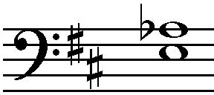
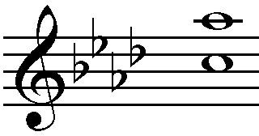
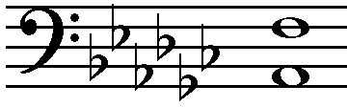
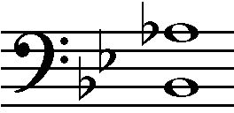
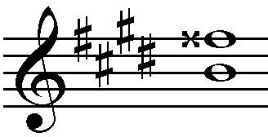

Key: D, Major
Key: A, flat-Major
Key: G, Major
Key: B, flat major
Key: E, major

Int.: Fourth Diminished
Int.: Minor sixth
Int.: Major sixth
Int.: Major seventh
Int.: Augmented fifth

- Draw and label the inversion of the given interval (10 marks)
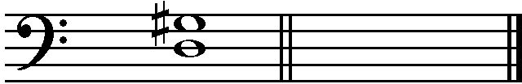
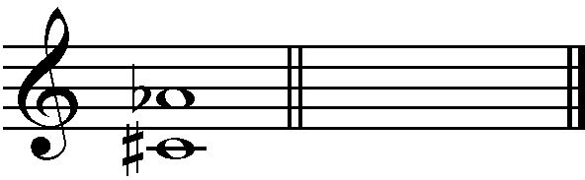
Interval: M6 Interval: Bb Major
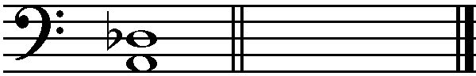
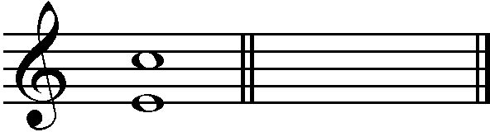
Interval:D5 Interval: M7

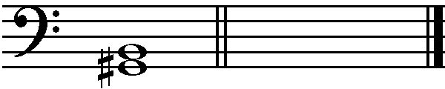
Interval: M3

- Draw the specified interval below the given note (melodic or harmonic) (5 marks)

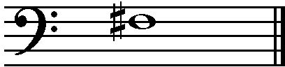
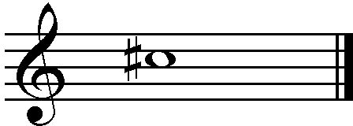
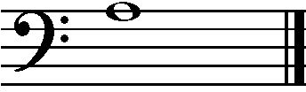
M7 P5 m6
G F-sharp C-double Sharp
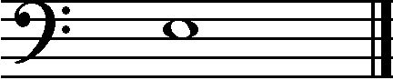
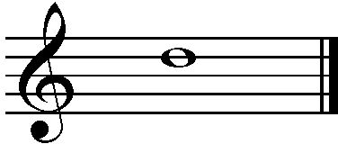
d3 M3
C-double sharp as well as the r G-flat A-double flat

- Identify the name and quality of the following triads (5 marks)

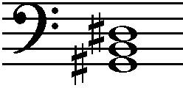
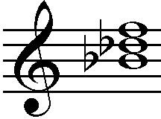
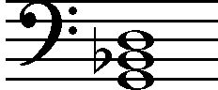
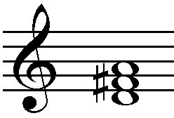
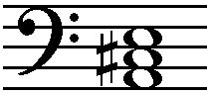

- G-sharp major triad
- B-flat minor triad
- G minor triad
- D major triad
- A major triad

- Identify the name, quality, and inversion (root, 1st, or 2nd) of the following triads (10 marks)
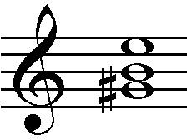
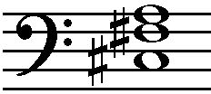
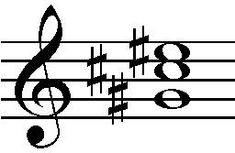
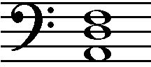
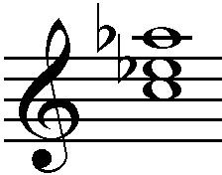
E- sharp, minor-triad ……………1st inversion
B-Flat, Minor triad ……………2nd inversion
C- sharp, Major triad …………..2nd inversion
D, flat minor triad……………2nd inversion
A-flat, Major triad……………1st inversion

- Answer the following questions about the given musical excerpt (10 marks)
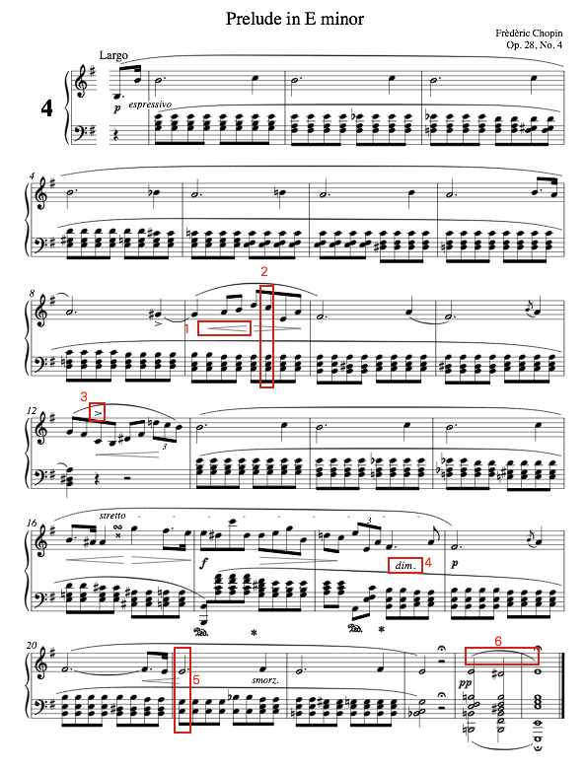

  - What is the initial dynamic level? Lento Asai
  - Who is the composer? Chopin
  - What is the symbol in box #1 and what does it mean? Crescendo-gradually louder
  - What key is the excerpt in?
  - What is the name and inversion of the chord in box #2?
  - What is the symbol in box #3 and what does it mean? Accent-the note is to be emphasized when its is played
  - What is the term in box #4 and what does it mean? Slur-The joint notes are to be played legato or smoothly.
  - Identify the bass note of the chord in box #5 by providing its technical name (tonic, supertonic, etc.) double sharp
  - What is the symbol in box #6 and what does it mean? Diminished Triad second inversion

  - What is the time signature of the excerpt? 4/4, since every measure has four beats

